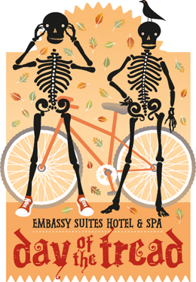 | Day of the Tread  Troop 1 Service Project  Sunday, October 24, 2010 | 
 |  | 

WHO: Scouts, Parents and “Old Goats” of Troop One!!!

WHAT: Halloween-themed charitable bike ride, walk, and certified 5K/10K run to benefit The Carrie Tingley Foundation, Casa Esperanza, and The Leukemia and Lymphoma Foundation. Scouts will man one of the cheering stations along the cycling routes encouraging the bikers on. Participation guarantees a ghoulish good-time.
http://www.dayofthetread.com

WHEN: Sunday, October 24, 2010

WHERE: West Mountain Rd at the intersection with the Rio Grande Bosque bike trail, along the Day of the Tread cycling route. The Start/Finish line for all events is at the Embassy Suites Hotel, 100 Woodward Pl NE [Lomas, just west of I-25].

TIMES: Be there at 8:30 am. Finish at 1:00 pm. Lunch served afterwards at Hotel.

BRING: CAMERA for Eagle Book pictures!!! Volunteers are encouraged to wear a Halloween costume [not required] if they wish to; however volunteer T-shirts will be given out. Since this is an outdoor event, Scouts are encouraged to bring their own drinks/snacks.

Emergency contacts: ~~ Brian Green 505/856-3684 / Brian Hanson 505/235-0427

------------------------ CUT HERE  ----------- CUT HERE  ---------- CUT HERE  ---------- CUT HERE  ---------------------- CUT HERE  -------------------

 COMMITMENT is due by Tues, October 19 ~ PLEASE PRINT 

Put Commitment Form in Mr. Kirson’s Hand … THANK YOU!!!

Scout’s Name ______________________________ Patrol _____________

Names of Parents Going: Dad ________________ Mom ______________
WE CAN DRIVE
I will be driving? _________________________________Cell # _________
Year Make Model #Seats
Adult T-shirt sizes for Scout & participating parents_____________________

